ADITYA S (240701020)
EXPERIMENT NO. 2
Setting Up a Zoho Creator Account and Exploring Its Platform Architecture and Interface

1. Aim
To set up a Zoho Creator account, build a simple sample application, create and examine forms, reports, and dashboards, and understand the main Develop, Deploy, and Manage areas of the Zoho Creator platform.

2. Setting Up Zoho Creator

I) Creating a Sample Application
First, a Zoho Creator account is created and the Creator workspace is accessed. A new blank application is then created to understand how the platform can be used to build an application without extensive programming.
1. Open Zoho Creator and sign in using an available account.
2. From the home page, choose the option to create a new application.
3. Select a blank application and enter a suitable application name.
4. Confirm the creation to open the application builder.
For this experiment, a sample application named “Corporate Asset Management” is used. It demonstrates how data can be entered through forms, viewed through reports, and presented visually using dashboards.
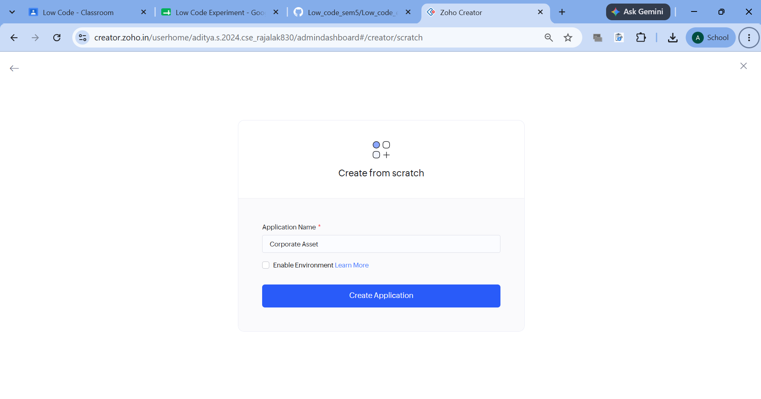

II) Creating a Form, Report and Dashboard

A. Creating a Form
A form is used to collect information from users and store the submitted records in the application. Fields such as text, number, date, email, dropdown, checkbox, phone number, and file upload can be added according to the application's requirements.
To create a form, select the form creation option, provide a suitable name, and add the required fields using the visual builder. Field properties such as data type, mandatory status, default values, and validation rules can be configured before saving the form.
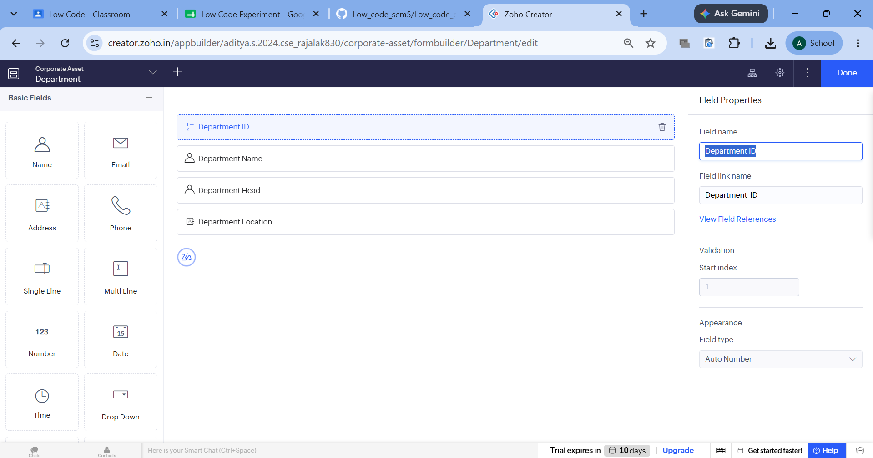
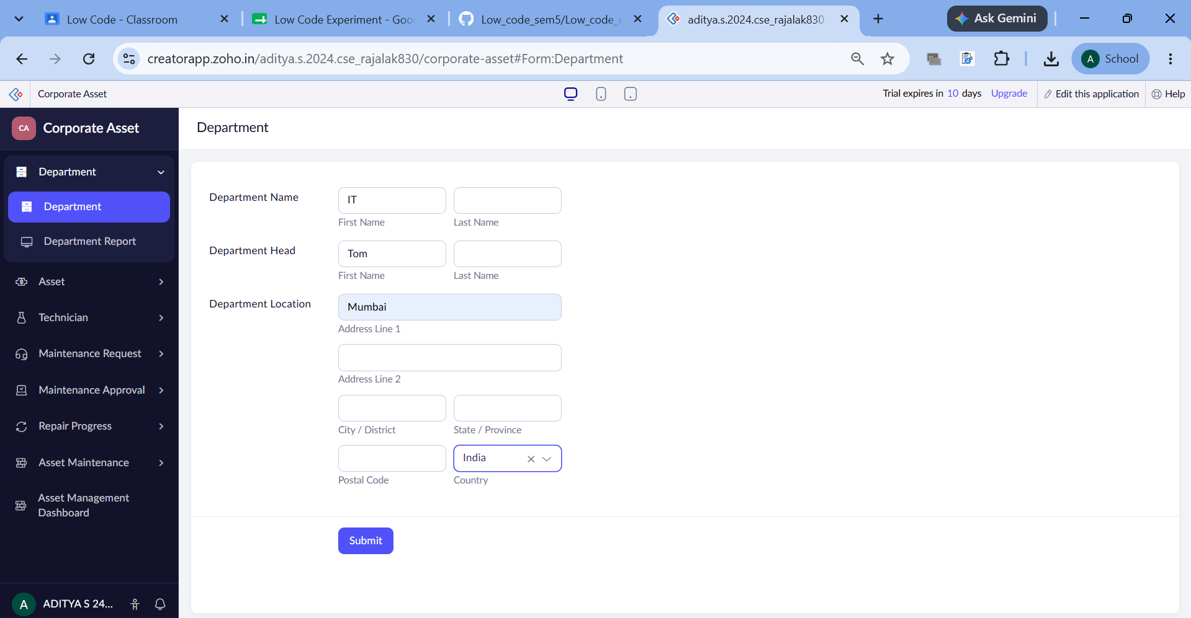

B. Creating a Report
A report displays the records collected through a form. It provides a convenient way to view, search, filter, sort, group, edit, and manage stored information.
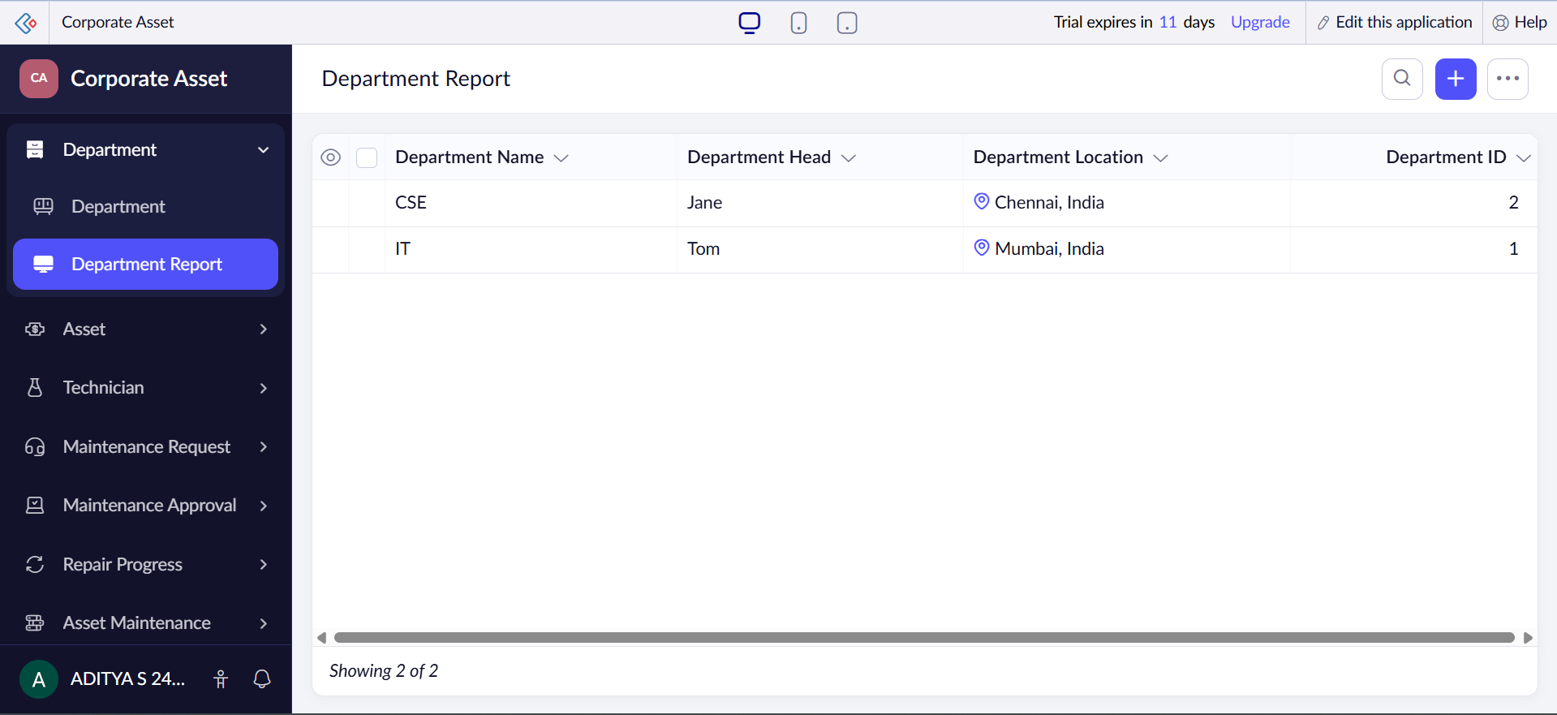

C. Creating a Dashboard
A dashboard provides a consolidated visual view of important application information. It can contain charts, reports, statistics, gauges, buttons, and other widgets so that users can understand key information quickly.
To create a dashboard, choose the dashboard option, give it a suitable name, and add the required components. The components can be arranged and resized to produce a clear and interactive layout.
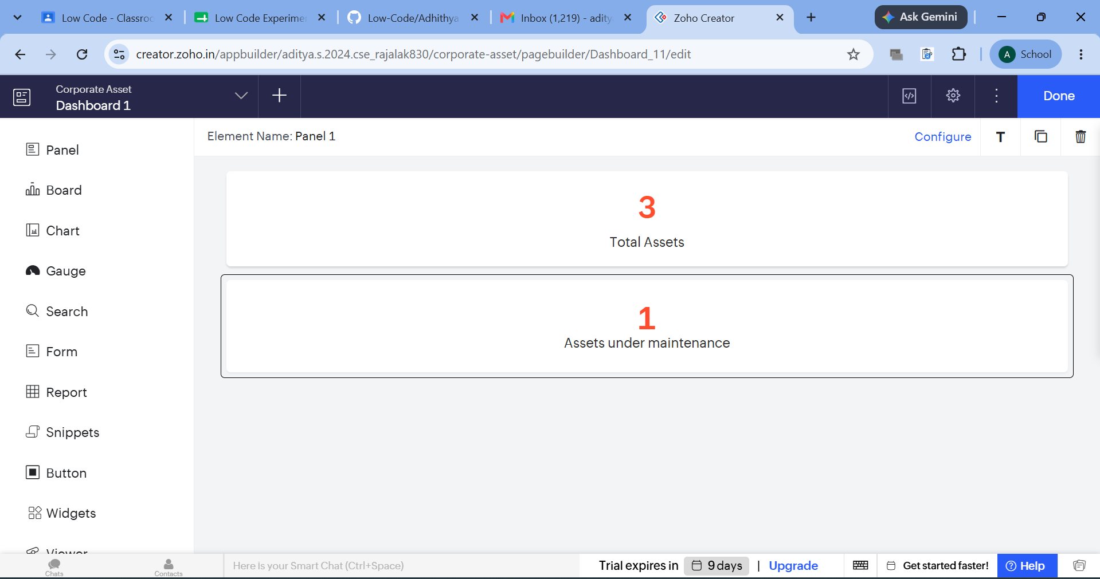

3. Exploring the Platform Architecture and Interface
Zoho Creator organizes application development and administration into three major areas: Develop, Deploy, and Manage. Each area supports a different stage of the application lifecycle.

A. Develop
• The Develop section is the main area for designing and building applications using visual, low-code tools.
• It allows users to create forms, reports, pages, dashboards, workflows, and schedules, while also configuring fields and application logic.
• Advanced requirements can be handled using Deluge scripting, integrations, relationships, and automation features.

B. Deploy
• The Deploy section is used to make a completed and tested application available to its intended users.
• Applications can be shared with selected users or organizations, with suitable access permissions configured for them.
• Updates and new versions can be published so that users receive the latest application changes.

C. Manage
• The Manage section is used for administration and maintenance after an application has been deployed.
• It provides controls for users, roles, permissions, security, usage monitoring, storage, backups, and related administrative tasks.
• This area helps maintain the application's reliability, security, and proper operation throughout its lifecycle.

Result
Thus, a Zoho Creator account was set up and a sample application was created successfully. The creation of forms, reports, and dashboards was studied, and the Develop, Deploy, and Manage sections of the platform were explored. The experiment provided an understanding of how Zoho Creator supports rapid application development through a low-code environment.

